**Wix**

Wix.com is an online website builder, it allows web making through the graphical interface and then can host the website directly. This means one can easily create a website without needing to code as much.

Reflection: The web-making GUI does not respond well to object alignment issues, and advance effects will be some programming knowledge

**Plotly and Pyechart**

Plotly and Pyechart are open-source data visualization libraries built for Python. We have chosen these two libraries as they provide powerful features while requiring less code. Furthermore, it supports more interactive charts, which will give the audience a better experience.

**Describe**

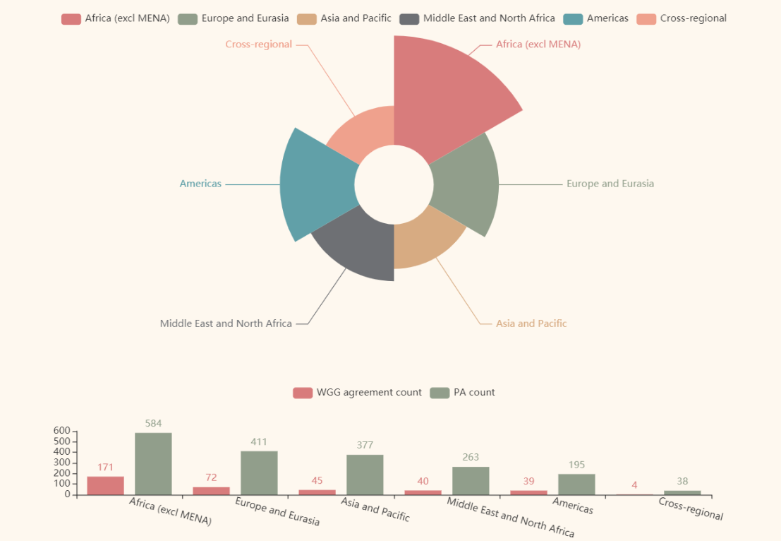

These graphs show the percentage of gender aspect in peace agreements by region. Through these graphs, we can force on the specific value holistically and find more correlative relationships.

Africa (excl MENA) has the largest number of peace agreements both in all and gender-related part, at the same time the proportion of there is also the highest. As previously analyzed, this is because of Africa's long history of violent conflicts.

Europe and Eurasia have a lot of peace agreements but just a few related to gender aspects. As a growing evidence and agreement admit the perspective that women’s participation is essential to sustainable peace. Perhaps the active participation of UN-Women in the region was one of the factors that influenced the results.